1. Create the following relationships in the data model.

1. In Product table,
   1. Insert the **Markup Price** column: Subtract Standard Cost from List Price
   2. Create a **Weight Group** column that categorizes the weight values into 5 bins.
2. Create a calculated table called **FirstPurchaseDate** using DAX. This table should include the following columns:
   1. Date [min(datefirstpurchase) … max(datefirstpurchase)]
   2. Day [1..31]
   3. Week day [Sun..Sat]
   4. Month [Jan..Dec]
   5. Month Number [1..12]
   6. Year
3. Create a new relationship between **FirstPurchaseDate[Date]** and **Customer[DateFirstPurchase]**
4. In Customer table, create a hierarchy with three levels – country, state and occupation
5. Hide the key fields in the data model
6. In Sales table
   1. Create a **Total Sales Amount** measure to sum the sales amount in the Sales table.
   2. Create **Total Sales by Current List Price** measure. Calculate the sum of the product of the current list price and order quantity.
7. In page 1 of the report,

* Insert a table visual showing **Total Sales Amount** by **Year** and **Month Name** from the Date table, sorted chronologically (Jan–Dec).

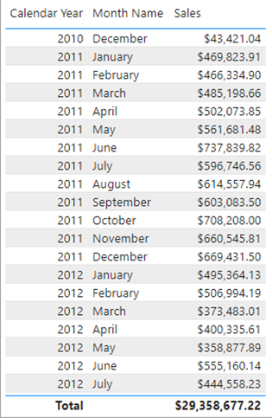

1. Create a **Total Sales by Due Date** measure to calculate total sales by enabling the inactive relationship between **Date[FullDate]** and **Sales[DueDate].**
2. Create a **Target Sales** measure to sum the **Target** in the **Target** table. Insert the following visual to check the measure's result.

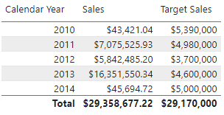

1. Create a **Profit** measure that fulfills the following criteria: it should exclude products with a color of NA, subtract the sum of sales amount from the sum of product standard cost, and divide the result by the sum of product standard cost. Reuse existing measures if required.
2. Create a measure named **Sales contribution %** that calculates the ratio of current sales to overall sales. Insert the following visual to check the measure's result.

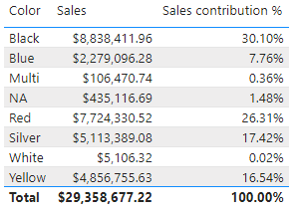

1. Create a measure called **High Salaried Customers** that counts the number of distinct customers who have bought at least one product and have a yearly income of $100,000 or more. Insert the following visual to check the measure's result.

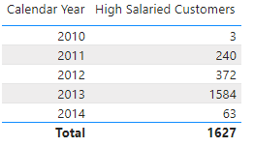

1. Create measures called **First Date Sales** and **Last Date Sales** to calculate sales on the first and last calendar day of the time period. Insert the following visual to check the measure's result.

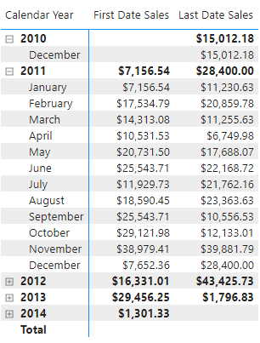

1. Create a measure named **Sales QTD** to calculate the total sales for the current quarter.